**ABSTRACT**

Many data mining techniques have been proposed for mining useful patterns in text documents. However, how to effectively use and update discovered patterns is still an open research issue, especially in the domain of text mining. Since most existing text mining methods adopted term-based approaches, they all suffer from the problems of polysemy and synonymy. Over the years, people have often held the hypothesis that pattern (or phrase)-based approaches should perform better than the term-based Ones, but many experiments do not support this hypothesis. This paper presents an innovative and effective pattern discovery technique which includes the processes of pattern deploying and pattern evolving, to improve the effectiveness of using and updating discovered patterns for finding relevant and interesting information. Substantial experiments on RCV1 data collection and TREC topics demonstrate that the proposed solution achieves encouraging performance.

1. **INTRODUCTION:**

DUE to the rapid growth of digital data made available in recent years, knowledge discovery and data mining have attracted a great deal of attention with an imminent need for turning such data into useful information and knowledge. Many applications, such as market analysis and business management, can benefit by the use of the information and knowledge extracted from a large amount of data. Knowledge discovery can be viewed as the process of nontrivial extraction of information from large databases, information that is implicitly presented in the data, previously unknown and potentially useful for users. Data mining is therefore an essential step in the process of knowledge discovery in databases.

In the past decade, a significant number of data mining techniques have been presented in order to perform different knowledge tasks. These techniques include association Rule mining, frequent item set mining, sequential pattern mining, maximum pattern mining, and closed pattern mining. Most of them are proposed for the purpose of developing efficient mining algorithms to find particular patterns within a reasonable and acceptable time frame. With a large number of patterns generated by using data mining approaches, how to effectively use and update these patterns is still an open research issue. In this paper, we focus on the development of a knowledge discovery model to effectively use and update the discovered patterns and apply it to the field of text mining.

**1.1 Problem Statement:**

Text mining is the discovery of interesting knowledge in text Documents. It is a challenging issue to find accurate knowledge (or features) in text documents to help users to find what they want.

1. Phrases have inferior statistical properties to terms,

2. They have low frequency of occurrence, and

3. There are large numbers of redundant and noisy phrases among them

**1.2 EXISTING SYSTEM:**

Since most existing text mining methods adopted term-based approaches, they all suffer from the problems of polysemy and synonymy. Over the years, people have often held the hypothesis that pattern (or phrase)-based approaches should perform better than the term-based ones, but many experiments do not support this hypothesis.

**1.3 PROPOSED SYSTEM:**

We provide an effective pattern discovery technique, which first calculates discovered specificities of patterns and then evaluates term weights according to the Distribution of terms in the discovered patterns rather than the distribution in documents for solving the misinterpretation problem. It also considers the influence of patterns from the negative training examples to find ambiguous (noisy) patterns and try to reduce their influence for the low-frequency problem. The process of updating ambiguous patterns can be referred as pattern evolution. The proposed approach can improve the accuracy of evaluating term weights because discovered patterns are more specific than whole documents.

We also conduct numerous experiments on the latest data collection, Reuters Corpus Volume 1 (RCV1) and Text Retrieval Conference (TREC) filtering topics, to evaluate the proposed technique. The results show that the proposed technique outperforms up-to-date data mining-based methods, concept-based models and the state-of-the-art term based methods.

**2. PROJECT SCENARIO:**

**2.1 Name of the Project**

EFFECTIVE PATTERN DISCOVERY FOR TEXT MINING

**2.2 Objectives**

1. Input Design is the process of converting a user-oriented description of the input into a computer-based system. This design is important to avoid errors in the data input process and show the correct direction to the management for getting correct information from the computerized system.

2. It is achieved by creating user-friendly screens for the data entry to handle large volume of data. The goal of designing input is to make data entry easier and to be free from errors. The data entry screen is designed in such a way that all the data manipulates can be performed. It also provides record viewing facilities.

3. When the data is entered it will check for its validity. Data can be entered with the help of screens. Appropriate messages are provided as when needed so that the user will not be in maize of instant. Thus the objective of input design is to create an input layout that is easy to follow

**2.3** **Users of the system**

1. Administrator
2. User

**2.4 Functional Requirements:**

**Input Design:**

The input design is the link between the information system and the user. It comprises the developing specification and procedures for data preparation and those steps are necessary to put transaction data in to a usable form for processing can be achieved by inspecting the computer to read data from a written or printed document or it can occur by having people keying the data directly into the system. The design of input focuses on controlling the amount of input required, controlling the errors, avoiding delay, avoiding extra steps and keeping the process simple. The input is designed in such a way so that it provides security and ease of use with retaining the privacy. Input Design considered the following things:’

* What data should be given as input?
* How the data should be arranged or coded?
* The dialog to guide the operating personnel in providing input.
* Methods for preparing input validations and steps to follow when error occur.

**Output Design**

A quality output is one, which meets the requirements of the end user and presents the information clearly. In any system results of processing are communicated to the users and to other system through outputs. In output design it is determined how the information is to be displaced for immediate need and also the hard copy output. It is the most important and direct source information to the user. Efficient and intelligent output design improves the system’s relationship to help user decision-making.

1. Designing computer output should proceed in an organized, well thought out manner; the right output must be developed while ensuring that each output element is designed so that people will find the system can use easily and effectively. When analysis design computer output, they should Identify the specific output that is needed to meet the requirements.

2. Select methods for presenting information.

3. Create document, report, or other formats that contain information produced by the system.

The output form of an information system should accomplish one or more of the following objectives.

* Convey information about past activities, current status or projections of the
* Future.
* Signal important events, opportunities, problems, or warnings.
* Trigger an action.
* Confirm an action.
  1. **Non-Functional Requirements**

Non-Functional Requirements are often called qualities of a system. Other terms for non-functional Requirements are “constraints”, “quality attributes”, “quality goals”, “quality of service requirements” and “non-behavioral requirements”. Qualities that are non-functional requirements can be divided into two main categories:

* 1. Execution qualities, such as security and usability, which are observable at run time.
  2. Evaluation qualities, such as testability, extensibility and scalability, which are embodied in the static structure of the software system.
  3. **Optional features:**

Xml, JavaScript, web server.

* 1. **User interface priority**

Buttons, image box, check box, list box, radio buttons, etc. . .

* 1. **Team Size**

4 Members

* 1. **Technologies to be used**

Visual Studio 2008, Data Base SQL Server 2005.

* 1. **Tools to be used**

ASP.NET, Visual C#

* 1. **Final Deliverable must include**

The Successful Completion and execution of project along with the approval and evaluation of the project.

* 1. **Advantages of using SQL server**
* We can store our data in the tabular form
* We can store large amount of data
* In this the registered users can be viewed

**3. DETAILED SRS**

**3.1 Purpose**

The main purpose of preparing this documentation is to give a general insight in to the analysis and requirements of the existing system or situation and for determining the operating characteristics of the system

**3.2 Scope**

This document plays a vital role in the software development life cycle (SDLC) and it describes the complete requirement of the system. It is meant for use by the developers and will be the basic during testing phase. Any changes made to the requirements in the future will have to go through formal change approval process.

**3.3 Definitions, Acronyms and abbreviations**

XML: Extensible Markup Language

PDF: Portable Document format

User: Registered User (Authenticated User)

**3.4 References:**

* Visual Studio .Net 2008 : Wrox Publications
* Professional ADO.NET : Wiley Publishing, Inc.
* SQL Server 2005 programming : Robert Vieira

**3.5 SYSTEM SPECIFICATION**

**Hardware Requirements:**

* System : Pentium IV 2.4 GHz.
* Hard Disk : 40 GB.
* Floppy Drive : 1.44 Mb.
* Monitor : 14’ Colour Monitor.
* Mouse : Optical Mouse.
* Ram : 512 Mb.
* Keyboard : 101 Keyboard.

**Software Requirements:**

* Operating system : Windows XP and IIS
* Coding Language : ASP.Net with C# SP1
* Data Base : SQL Server 2005.

**3.6 SYSTEM STUDY**

**FEASIBILITY STUDY**

The feasibility of the project is analyzed in this phase and business proposal is put forth with a very general plan for the project and some cost estimates. During system analysis the feasibility study of the proposed system is to be carried out. This is to ensure that the proposed system is not a burden to the company. For feasibility analysis, some understanding of the major requirements for the system is essential. Three key considerations involved in the feasibility analysis are

* ECONOMICAL FEASIBILITY
* TECHNICAL FEASIBILITY
* SOCIAL FEASIBILITY

**ECONOMICAL FEASIBILITY**

This study is carried out to check the economic impact that the system will have on the organization. The amount of fund that the company can pour into the research and development of the system is limited. The expenditures must be justified. Thus the developed system as well within the budget and this was achieved because most of the technologies used are freely available. Only the customized products had to be purchased.

**TECHNICAL FEASIBILITY**

This study is carried out to check the technical feasibility, that is, the technical requirements of the system. Any system developed must not have a high demand on the available technical resources. This will lead to high demands on the available technical resources. This will lead to high demands being placed on the client. The developed system must have a modest requirement, as only minimal or null changes are required for implementing this system.

**SOCIAL FEASIBILITY**

The aspect of study is to check the level of acceptance of the system by the user. This includes the process of training the user to use the system efficiently. The user must not feel threatened by the system, instead must accept it as a necessity. The level of acceptance by the users solely depends on the methods that are employed to educate the user about the system and to make him familiar with it. His level of confidence must be raised so that he is also able to make some constructive criticism, which is welcomed, as he is the final user of the system

**4. Features of .NET**

Microsoft .NET is a set of Microsoft software technologies for rapidly building and integrating XML Web services, Microsoft Windows-based applications, and Web solutions. The .NET Framework is a language-neutral platform for writing programs that can easily and securely interoperate. There’s no language barrier with .NET: there are numerous languages available to the developer including Managed C++, C#, Visual Basic and Java Script. The .NET framework provides the foundation for components to interact seamlessly, whether locally or remotely on different platforms. It standardizes common data types and communications protocols so that components created in different languages can easily interoperate.

“.NET” is also the collective name given to various software components built upon the .NET platform. These will be both products (Visual Studio.NET and Windows.NET Server, for instance) and services (like Passport, .NET My Services, and so on).

**THE .NET FRAMEWORK**

The .NET Framework has two main parts:

1. The Common Language Runtime (CLR).

2. A hierarchical set of class libraries.

The CLR is described as the “execution engine” of .NET. It provides the environment within which programs run. The most important features are

* Conversion from a low-level assembler-style language, called Intermediate Language (IL), into code native to the platform being executed on.
* Memory management, notably including garbage collection.
* Checking and enforcing security restrictions on the running code.
* Loading and executing programs, with version control and other such features.
* The following features of the .NET framework are also worth description:

**Managed Code**

The code that targets .NET, and which contains certain extra

Information - “metadata” - to describe itself. Whilst both managed and unmanaged code can run in the runtime, only managed code contains the information that allows the CLR to guarantee, for instance, safe execution and interoperability.

**Managed Data**

With Managed Code comes Managed Data. CLR provides memory allocation and Deal location facilities, and garbage collection. Some .NET languages use Managed Data by default, such as C#, Visual Basic.NET and JScript.NET, whereas others, namely C++, do not. Targeting CLR can, depending on the language you’re using, impose certain constraints on the features available. As with managed and unmanaged code, one can have both managed and unmanaged data in .NET applications - data that doesn’t get garbage collected but instead is looked after by unmanaged code.

**Common Type System**

The CLR uses something called the Common Type System (CTS) to strictly enforce type-safety. This ensures that all classes are compatible with each other, by describing types in a common way. CTS define how types work within the runtime, which enables types in one language to interoperate with types in another language, including cross-language exception handling. As well as ensuring that types are only used in appropriate ways, the runtime also ensures that code doesn’t attempt to access memory that hasn’t been allocated to it.

**Common Language Specification**

The CLR provides built-in support for language interoperability. To ensure that you can develop managed code that can be fully used by developers using any programming language, a set of language features and rules for using them called the Common Language Specification (CLS) has been defined. Components that follow these rules and expose only CLS features are considered CLS-compliant.

**THE CLASS LIBRARY**

.NET provides a single-rooted hierarchy of classes, containing over 7000 types. The root of the namespace is called System; this contains basic types like Byte, Double, Boolean, and String, as well as Object. All objects derive from System. Object. As well as objects, there are value types. Value types can be allocated on the stack, which can provide useful flexibility. There are also efficient means of converting value types to object types if and when necessary.

The set of classes is pretty comprehensive, providing collections, file, screen, and network I/O, threading, and so on, as well as XML and database connectivity.

The class library is subdivided into a number of sets (or namespaces), each providing distinct areas of functionality, with dependencies between the namespaces kept to a minimum.

**LANGUAGES SUPPORTED BY ASP.NET**

A Microsoft server-side Web technology. ASP.NET takes an object-oriented programming approach to Web page execution. Every element in an ASP.NET page is treated as an object and run on the server. An ASP.NET page get compiled into an intermediate language by a .NET Common Language Runtime-compliant compiler. Then a JIT compiler turns the intermediate code to native machine code, and that machine code is eventually run on the processor. Because the code is run straight from the processor, pages load much faster than classic ASP pages, where embedded VBsricpt orJscript had to be continuously interpreted and cached.

ASP.NET is used to create Web pages and Web services and is an integral part of Microsoft's .NET vision.

ASP.NET is a development framework for building web pages and web sites with HTML, CSS, JavaScript and server scripting.ASP.NET supports three different development models:  
Web Pages, MVC (Model View Controller), and Web Forms:

The traditional ASP.NET event driven development model:Web pages with added server controls, server events, and server code.Web Pages is the easiest development model for developing ASP.NET web sites.

Web Forms is the traditional ASP.NET model, based on event driven Web Forms and post backs.Over the years, developers have used ASP.NET Web Forms to create many of the largest websites in the world.

ASP.NET is a unified Web development model that includes the services necessary for you to build enterprise-class Web applications with a minimum of coding. ASP.NET is part of the .NET Framework, and when coding ASP.NET applications you have access to classes in the .NET Framework. You can code your applications in any language compatible with the common language runtime (CLR), including Microsoft Visual Basic and C#. These languages enable you to develop ASP.NET applications that benefit from the common language runtime, type safety, inheritance, and so on.

|  |
| --- |
| If you want to try ASP.NET, you can install Visual Web Developer Express using the [Microsoft Web Platform Installer](http://go.microsoft.com/fwlink/?LinkId=153787), which is a free tool that makes it simple to download, install, and service components of the Microsoft Web Platform. These components include Visual Web Developer Express, Internet Information Services (IIS), SQL Server Express, and the .NET Framework. All of these are tools that you use to create ASP.NET Web applications. You can also use the Microsoft Web Platform Installer to install open-source ASP.NET and PHP Web applications. |

This topic describes the following features of ASP.NET and of Visual Web Developer, the development environment for creating ASP.NET applications.

* [Visual Web Developer](http://msdn.microsoft.com/en-us/library/4w3ex9c2.aspx#VisualWebDeveloper)
* [ASP.NET Web Sites and ASP.NET Web Application Projects](http://msdn.microsoft.com/en-us/library/4w3ex9c2.aspx#ASPNETWebSitesAndASPNETWebApplicationProjects)
* [ASP.NET API Reference](http://msdn.microsoft.com/en-us/library/4w3ex9c2.aspx#aspnet_api_reference)
* [Page and Controls Framework](http://msdn.microsoft.com/en-us/library/4w3ex9c2.aspx#PageAndControlsFramework)
* [ASP.NET Compiler](http://msdn.microsoft.com/en-us/library/4w3ex9c2.aspx#ASPNETCompiler)
* [Security Infrastructure](http://msdn.microsoft.com/en-us/library/4w3ex9c2.aspx#SecurityInfrastructure)
* [State-Management Facilities](http://msdn.microsoft.com/en-us/library/4w3ex9c2.aspx#StateManagementFacilities)
* [ASP.NET Configuration](http://msdn.microsoft.com/en-us/library/4w3ex9c2.aspx#ASPNETConfiguration)
* [Health Monitoring and Performance Features](http://msdn.microsoft.com/en-us/library/4w3ex9c2.aspx#HealthMonitoringAndPerformanceFeatures)
* [Debugging Support](http://msdn.microsoft.com/en-us/library/4w3ex9c2.aspx#DebuggingSupport)
* [Web Services Framework](http://msdn.microsoft.com/en-us/library/4w3ex9c2.aspx#XMLWebServicesFramework)
* [Extensible Hosting Environment and Application Life-Cycle Management](http://msdn.microsoft.com/en-us/library/4w3ex9c2.aspx#ExtensibleHostingEnvironment)
* [Extensible Designer Environment](http://msdn.microsoft.com/en-us/library/4w3ex9c2.aspx#ExtensibleDesignerEnvironment)
* [Web Applications Based on the MVC Pattern](http://msdn.microsoft.com/en-us/library/4w3ex9c2.aspx#MVC)
* ASP.NET Dynamic Data

[**Visual Web Developer**](javascript:void(0))

Visual Web Developer is a full-featured development environment for creating ASP.NET Web applications. Visual Web Developer offers you the following features:

* Web page design   A powerful Web page editor that includes WYSIWYG editing and an HTML editing mode with IntelliSense and validation.
* Page design features   Consistent site layout with master pages and consistent page appearance with themes and skins.
* Code editing   A code editor that enables you to write code for your dynamic Web pages in Visual Basic or C#. The code editor includes syntax coloration and IntelliSense.
* Testing and Debugging   A local Web server for testing and a debugger that helps you find errors in your programs.
* Deployment   Tools to automate typical tasks for deploying a Web application to a hosting server or a hosting provider.

### Testing and Debugging

Visual Web Developer provides an ideal environment in which to build Web sites and then publish them to a hosting site. Using the development tools in Visual Web Developer, you can develop ASP.NET Web pages on your own computer. Visual Web Developer includes a local Web server that provides all the features you need to test and debug ASP.NET Web pages, without requiring Internet Information Services (IIS) to be installed.

When your site is ready, you can publish it to the host computer using the built-in Copy Web tool, which transfers your files when you are ready to share them with others. Alternatively, you can precompile and deploy a Web site by using the Build Web Site command. The Build Web Site command runs the compiler over the entire Web site (not just the code files) and produces a Web site layout that you can deploy to a production server.

.[**ASP.NET Web Sites and ASP.NET Web Application Projects**](javascript:void(0))**:**

Using Visual Studio 2010, you can create different types of ASP.NET projects, which includes Web sites, Web applications, Web services, and AJAX server controls.

There is a difference between Web site projects and Web application projects. Some features work only with Web application projects, such as MVC and certain tools for automating Web deployment. Other features, such as Dynamic Data, work with both Web sites and Web application projects. For more information about the differences between Web application projects and Web site projects, see [Web Application Projects versus Web Site Projects](http://msdn.microsoft.com/en-us/library/dd547590.aspx).

[**ASP.NET API Reference**](javascript:void(0))

Some of the most important namespaces in the .NET Framework class library that pertain to ASP.NET are the following:

[**System.Web**](http://msdn.microsoft.com/en-us/library/system.web.aspx)

Provides classes and interfaces that enable browser-server communication. This namespace includes the [HttpRequest](http://msdn.microsoft.com/en-us/library/system.web.httprequest.aspx) class, which provides extensive information about the current HTTP request, the [HttpResponse](http://msdn.microsoft.com/en-us/library/system.web.httpresponse.aspx) class, which manages HTTP output to the client, and the [HttpServerUtility](http://msdn.microsoft.com/en-us/library/system.web.httpserverutility.aspx) class, which provides access to server-side utilities and processes. [System.Web](http://msdn.microsoft.com/en-us/library/system.web.aspx) also includes classes for cookie manipulation, file transfer, exception information, and output cache control.

[**System.Web.ApplicationServices**](http://msdn.microsoft.com/en-us/library/system.web.applicationservices.aspx)

Provides classes that provide access to ASP.NET forms authentication, roles, and profiles application services as Windows Communication Foundation (WCF) services.

[**System.Runtime.Caching**](http://msdn.microsoft.com/en-us/library/system.runtime.caching.aspx)

Contains types that let you implement caching in .NET Framework applications.

[**System.Web.ClientServices**](http://msdn.microsoft.com/en-us/library/system.web.clientservices.aspx)

Contains classes that support access to the ASP.NET login, roles, and profiles services from Windows-based applications.

[**System.Web.Configuration**](http://msdn.microsoft.com/en-us/library/system.web.configuration.aspx)

Contains classes that are used to programmatically manage ASP.NET configuration. (Most configuration settings can be made in XML files.)

[**System.Web.DynamicData**](http://msdn.microsoft.com/en-us/library/system.web.dynamicdata.aspx)

Contains classes that provide the core functionality for ASP.NET dynamic data and extensibility features that let you customize dynamic data behavior.

[**System.Web.Handlers**](http://msdn.microsoft.com/en-us/library/system.web.handlers.aspx)

Contains HTTP handler classes that process HTTP requests to a Web server. (An ASP.NET Web Forms page -- .aspx file -- is a special form of an HTTP handler.)

[**System.Web.Management**](http://msdn.microsoft.com/en-us/library/system.web.management.aspx)

Contains classes and interfaces for managing and monitoring the health of Web applications.

[**System.Web.Profile**](http://msdn.microsoft.com/en-us/library/system.web.profile.aspx)

Contains classes that are used to implement the ASP.NET user profile in Web server applications.

[**System.Web.Query.Dynamic**](http://msdn.microsoft.com/en-us/library/system.web.query.dynamic.aspx)

Contains classes that are used to parse expressions from a [LinqDataSource](http://msdn.microsoft.com/en-us/library/system.web.ui.webcontrols.linqdatasource.aspx) control into a Language-Integrated Query (LINQ).

[**System.Web.RegularExpressions**](http://msdn.microsoft.com/en-us/library/system.web.regularexpressions.aspx)

Provides regular expressions that are used to parse ASP.NET files. All members of the [System.Web.RegularExpressions](http://msdn.microsoft.com/en-us/library/system.web.regularexpressions.aspx) namespace are descendants of the [Regex](http://msdn.microsoft.com/en-us/library/system.text.regularexpressions.regex.aspx) class. (You typically do not have to parse ASP.NET pages yourself.)

[**System.Web.Routing**](http://msdn.microsoft.com/en-us/library/system.web.routing.aspx)

Provides classes that are used with URL routing, which enables you to use URLs that do not map to a physical file.

[**System.Web.Script**](http://msdn.microsoft.com/en-us/library/system.web.script.aspx)

Contains classes that provide client-script resource information.

[**System.Web.Script.Services**](http://msdn.microsoft.com/en-us/library/system.web.script.services.aspx)

Provides attributes to customize Web service support for using Ajax functionality in ASP.NET.

[**System.Web.Security**](http://msdn.microsoft.com/en-us/library/system.web.security.aspx)

Contains classes that are used to implement ASP.NET security in Web server applications.

[**System.Web.Services**](http://msdn.microsoft.com/en-us/library/system.web.services.aspx)

Consists of the classes that enable you to create XML Web services using ASP.NET and XML Web service clients. XML Web services are applications that provide the ability to exchange messages in a loosely coupled environment using standard protocols such as HTTP, XML, XSD, SOAP, and WSDL. XML Web services let you build modular applications that are interoperable across a broad variety of implementations, platforms, and devices.

[**System.Web.SessionState**](http://msdn.microsoft.com/en-us/library/system.web.sessionstate.aspx)

Contains classes and interfaces that enable storage of data specific to a single client during a single browser session on the server. Session state data is used to give the client the appearance of a persistent connection with the application.

**C#.NET:**

**C#** (pronounced as *see sharp*) is a [multi-paradigm programming language](http://en.wikipedia.org/wiki/Multi-paradigm_programming_language) encompassing [strong typing](http://en.wikipedia.org/wiki/Strong_typing), [imperative](http://en.wikipedia.org/wiki/Imperative_programming), [declarative](http://en.wikipedia.org/wiki/Declarative_programming), [functional](http://en.wikipedia.org/wiki/Functional_programming), [procedural](http://en.wikipedia.org/wiki/Procedural_programming), [generic](http://en.wikipedia.org/wiki/Generic_programming), [object-oriented](http://en.wikipedia.org/wiki/Object-oriented_programming) ([class](http://en.wikipedia.org/wiki/Class_%28computer_science%29)-based), and [component-oriented](http://en.wikipedia.org/wiki/Component-based_software_engineering) programming disciplines. It was developed by [Microsoft](http://en.wikipedia.org/wiki/Microsoft) within its [.NET](http://en.wikipedia.org/wiki/.NET_Framework) initiative and later approved as a standard by [Ecma](http://en.wikipedia.org/wiki/Ecma_International) (ECMA-334) and [ISO](http://en.wikipedia.org/wiki/International_Organization_for_Standardization) (ISO/IEC 23270:2006). C♯ is one of the programming languages designed for the [Common Language Infrastructure](http://en.wikipedia.org/wiki/Common_Language_Infrastructure). C♯ is built on the syntax and semantics of C++, allowing C programmers to take advantage of .NET and the common language runtime.

C# syntax is highly expressive, yet it is also simple and easy to learn. The curly-brace syntax of C# will be instantly recognizable to anyone familiar with C, C++ or Java. Developers who know any of these languages are typically able to begin to work productively in C# within a very short time. C# syntax simplifies many of the complexities of C++ and provides powerful features such as nullable value types, enumerations, delegates, lambda expressions and direct memory access, which are not found in Java. C# supports generic methods and types, which provide increased type safety and performance, and iterators, which enable implementers of collection classes to define custom iteration behaviors that are simple to use by client code. Language-Integrated Query (LINQ) expressions make the strongly-typed query a first-class language construct.

As an object-oriented language, C# supports the concepts of encapsulation, inheritance, and polymorphism. All variables and methods, including the Main method, the application's entry point, are encapsulated within class definitions. A class may inherit directly from one parent class, but it may implement any number of interfaces. Methods that override virtual methods in a parent class require the override keyword as a way to avoid accidental redefinition. In C#, a struct is like a lightweight class; it is a stack-allocated type that can implement interfaces but does not support inheritance.

In addition to these basic object-oriented principles, C# makes it easy to develop software components through several innovative language constructs, including the following:

* Encapsulated method signatures called delegates, which enable type-safe event notifications.
* Properties, which serve as accessors for private member variables.
* Attributes, which provide declarative metadata about types at run time.
* Inline XML documentation comments.
* Language-Integrated Query (LINQ) which provides built-in query capabilities across a variety of data sources.

If you have to interact with other Windows software such as COM objects or native Win32 DLLs, you can do this in C# through a process called "Interop." Interop enables C# programs to do almost anything that a native C++ application can do. C# even supports pointers and the concept of "unsafe" code for those cases in which direct memory access is absolutely critical.

The C# build process is simple compared to C and C++ and more flexible than in Java. There are no separate header files, and no requirement that methods and types be declared in a particular order. A C# source file may define any number of classes, structs, interfaces, and events.

The following are additional C# resources:

* For a good general introduction to the language, see Chapter 1 of the [C# Language Specification](http://msdn.microsoft.com/en-us/library/ms228593.aspx).
* For detailed information about specific aspects of the C# language, see the [C# Reference](http://msdn.microsoft.com/en-us/library/618ayhy6.aspx).
* For more information about LINQ, see [LINQ (Language-Integrated Query)](http://msdn.microsoft.com/en-us/library/bb397926.aspx).
* To find the latest articles and resources from the Visual C# team, see the [Visual C# Developer Center](http://go.microsoft.com/fwlink/?LinkId=47811).

C# is Microsoft’s new language. It’s a C-style language that is essentially “C++ for Rapid Application Development”. Unlike other languages, its specification is just the grammar of the language. It has no standard library of its own, and instead has been designed with the intention of using the .NET libraries as its own.

Microsoft Visual C# .NET provides the easiest transition for Java-language developers into the world of XML Web Services and dramatically improves the interoperability of Java-language programs with existing software written in a variety of other programming languages.

Active State has created Visual Perl and Visual Python, which enable .NET-aware applications to be built in either Perl or Python. Both products can be integrated into the Visual Studio .NET environment. Visual Perl includes support for Active State’s Perl Dev Kit.

Other languages for which .NET compilers are available include

* FORTRAN
* COBOL
* Eiffel

Fig1 **.**Net Framework

|  |  |
| --- | --- |
| ASP.NET  XML WEB SERVICES | Windows Forms |
| Base Class Libraries | |
| Common Language Runtime | |
| Operating System | |

C#.NET is also compliant with CLS (Common Language Specification) and supports structured exception handling. CLS is set of rules and constructs that are supported by the CLR (Common Language Runtime). CLR is the runtime environment provided by the .NET Framework; it manages the execution of the code and also makes the development process easier by providing services.

C#.NET is a CLS-compliant language. Any objects, classes, or components that created in C#.NET can be used in any other CLS-compliant language. In addition, we can use objects, classes, and components created in other CLS-compliant languages in C#.NET .The use of CLS ensures complete interoperability among applications, regardless of the languages used to create the application.

**CONSTRUCTORS AND DESTRUCTORS:**

Constructors are used to initialize objects, whereas destructors are used to destroy them. In other words, destructors are used to release the resources allocated to the object. In C#.NET the sub finalize procedure is available. The sub finalize procedure is used to complete the tasks that must be performed when an object is destroyed. The sub finalize procedure is called automatically when an object is destroyed. In addition, the sub finalize procedure can be called only from the class it belongs to or from derived classes.

**GARBAGE COLLECTION**

Garbage Collection is another new feature in C#.NET. The .NET Framework monitors allocated resources, such as objects and variables. In addition, the .NET Framework automatically releases memory for reuse by destroying objects that are no longer in use.

In C#.NET, the garbage collector checks for the objects that are not currently in use by applications. When the garbage collector comes across an object that is marked for garbage collection, it releases the memory occupied by the object.

**OVERLOADING**

Overloading is another feature in C#. Overloading enables us to define multiple procedures with the same name, where each procedure has a different set of arguments. Besides using overloading for procedures, we can use it for constructors and properties in a class.

**MULTITHREADING:**

C#.NET also supports multithreading. An application that supports multithreading can handle multiple tasks simultaneously, we can use multithreading to decrease the time taken by an application to respond to user interaction.

**STRUCTURED EXCEPTION HANDLING**

C#.NET supports structured handling, which enables us to detect and remove errors at runtime. In C#.NET, we need to use Try…Catch…Finally statements to create exception handlers. Using Try…Catch…Finally statements, we can create robust and effective exception handlers to improve the performance of our application.

**THE .NET FRAMEWORK**

The .NET Framework is a new computing platform that simplifies application development in the highly distributed environment of the Internet.

**OBJECTIVES OF. NET FRAMEWORK**

1. To provide a consistent object-oriented programming environment whether object codes is stored and executed locally on Internet-distributed, or executed remotely.

2. To provide a code-execution environment to minimizes software deployment and guarantees safe execution of code.

3. Eliminates the performance problems.

There are different types of application, such as Windows-based applications and Web-based applications.

The OLAP Services feature available in SQL Server version 7.0 is now called SQL Server 2000 Analysis Services. The term OLAP Services has been replaced with the term Analysis Services. Analysis Services also includes a new data mining component. The Repository component available in SQL Server version 7.0 is now called Microsoft SQL Server 2000 Meta Data Services. References to the component now use the term Meta Data Services. The term repository is used only in reference to the repository engine within Meta Data Services

SQL-SERVER database consist of six type of objects,

They are,

1. TABLE

2. QUERY

3. FORM

4. REPORT

5. MACRO

**TABLE:**

A database is a collection of data about a specific topic.

**VIEWS OF TABLE:**

We can work with a table in two types,

1. Design View

2. Datasheet View

**Design View**

To build or modify the structure of a table we work in the table design view. We can specify what kind of data will be hold.

**Datasheet View**

To add, edit or analyses the data itself we work in tables datasheet view mode.

**QUERY:**

A query is a question that has to be asked the data. Access gathers data that answers the question from one or more table. The data that make up the answer is either dynaset (if you edit it) or a snapshot (it cannot be edited).Each time we run query, we get latest information in the dynaset. Access either displays the dynaset or snapshot for us to view or perform an action on it, such as deleting or updating.

**5. Overall Description**

Implementation is the stage of the project when the theoretical design is turned out into a working system. Thus it can be considered to be the most critical stage in achieving a successful new system and in giving the user, confidence that the new system will work and be effective.

The implementation stage involves careful planning, investigation of the existing system and it’s constraints on implementation, designing of methods to achieve changeover and evaluation of changeover methods.

**Main Modules:**

1. PATTERN TAXONOMY MODEL
2. PATTERN DEPLOYING METHOD
3. INNER PATTERN EVOLUTION
4. PATTERN TAXONOMY MODEL :

We assume that all documents are split into paragraphs. So a given document d yields a set of paragraphs. Let D be a training set of documents, which consists of a set of positive documents and a set of negative documents.

1. PATTERN DEPLOYING METHOD :

In order to use the semantic information in the pattern taxonomy to improve the performance of closed patterns in text mining, we need to interpret discovered patterns by summarizing them as d-patterns (see the definition below) in order to accurately evaluate term weights (supports). The rational behind this motivation is that d-patterns include more semantic meaning than terms that are selected based on a term-based technique (e.g., tf*idf).

1. INNER PATTERN EVOLUTION :

We discuss how to reshuffle supports of terms within normal forms of d-patterns based on negative documents in the training set. The technique will be useful to reduce the side effects of noisy patterns because of the low- frequency problem. This technique is called inner pattern evolution here, because it only changes a pattern’s term supports within the pattern. A threshold is usually used to classify documents into relevant or irrelevant categories. The proposed model includes two phases: the training phase and the testing phase.

In the training phase, the proposed model first calls Algorithm PTM (Dþ, min sup) to find d-patterns in positive documents (Dþ) based on a min sup, and evaluates term supports by deploying d-patterns to terms. It also calls Algorithm IPEvolving (Dþ, D_, DP, _) to revise term supports using noise negative documents in D_ based on an experimental coefficient _. In the testing phase, it evaluates weights for all incoming documents using eq. (4). The incoming documents then can be sorted based on these weights.

**6. Design**

**UML**

UML is a method for describing the system architecture in detail using the blueprint.

UML represents a collection of best engineering practices that have proven successful in the modeling of large and complex systems.

UML is a very important part of developing objects oriented software and the software development process.

UML uses mostly graphical notations to express the design of software projects.

Using the UML helps project teams communicate, explore potential designs, and validate the architectural design of the software.

**Definition:**

UML is a general-purpose visual modeling language that is used to specify, visualize, construct, and document the artifacts of the software system.

**UML is a language:**

It will provide vocabulary and rules for communications and function on conceptual and physical representation. So it is modeling language.

**UML Specifying:**

Specifying means building models that are precise, unambiguous and complete. In particular, the UML address the specification of all the important analysis, design and implementation decisions that must be made in developing and displaying a software intensive system.

**UML Visualization:**

The UML includes both graphical and textual representation. It makes easy to visualize the system and for better understanding.

**UML Constructing:**

UML models can be directly connected to a variety of programming languages and it is sufficiently expressive and free from any ambiguity to permit the direct execution of models.

**UML Documenting:**

UML provides variety of documents in addition raw executable codes.

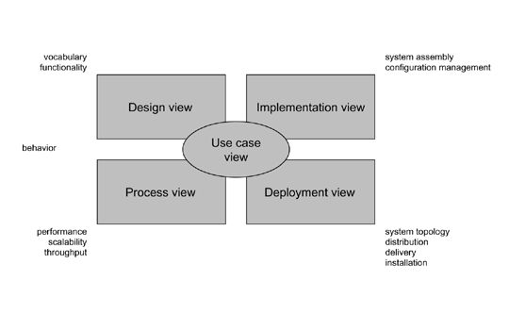 **Figure no 1: Modeling a System Architecture using views of UML**

The use case view of a system encompasses the use cases that describe the behavior of the system as seen by its end users, analysts, and testers.

The design view of a system encompasses the classes, interfaces, and collaborations that form the vocabulary of the problem and its solution.

The process view of a system encompasses the threads and processes that form the system's concurrency and synchronization mechanisms.

The implementation view of a system encompasses the components and files that are used to assemble and release the physical system. The deployment view of a system encompasses the nodes that form the system's hardware topology on which the system executes.

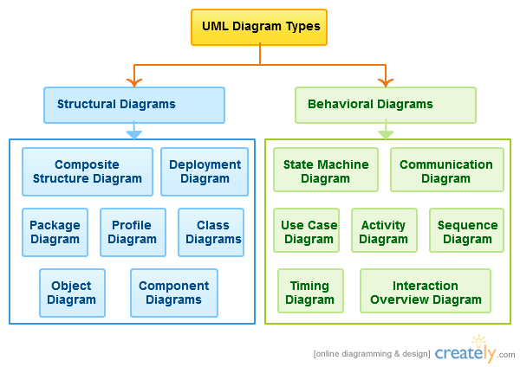

**Figure 2: UML diagram types**

**Uses of UML:**

The UML is intended primarily for software intensive systems. It has been used effectively for such domain as

Enterprise Information System

Banking and Financial Services

Telecommunications

Transportation

Defense/Areas

Retails

Medical Electronics

Scientific Fields

Distributed Web

**Building blocks of UML:**

The vocabulary of the UML encompasses 3 kinds of building blocks

Things

Relationships

Diagrams

**Things:**

Things are the data abstractions that are first class citizens in a model. Things are of 4 types

Structural Things, Behavioral Things, Grouping Things, notational Things

**Relationships:**

Relationships tie the things together. Relationships in the UML are

Dependency, Association, Generalization, Specialization

**UML Diagrams:**

A diagram is the graphical presentation of a set of elements, most often rendered as a connected graph of vertices (things) and arcs (relationships).

There are two types of diagrams, they are:

Structural and Behavioral Diagrams

**Structural Diagrams:-**

The UML‘s four structural diagrams exist to visualize, specify, construct and document the static aspects of a system. ican View the static parts of a system using one of the following diagrams. Structural diagrams consist of Class Diagram, Object Diagram, Component Diagram, Deployment Diagram.

**Behavioral Diagrams:**

The UML’s five behavioral diagrams are used to visualize, specify, construct, and document the dynamic aspects of a system. The UML’s behavioral diagrams are roughly organized around the major ways which can model the dynamics of a system.

Behavioral diagrams consists of Use case Diagram, Sequence Diagram, Collaboration Diagram, class diagram.

**6.1 Class Diagram**

A **class diagram** in the Unified Modeling Language (UML) is a type of static structure diagram that describes the structure of a system by showing the system's classes, their attributes, and the relationships between the classes.

The class diagram is the main building block in object oriented modeling. They are being used both for general conceptual modeling of the systematic of the application, and for detailed modeling translating the models into programming code. The classes in a class diagram represent both the main objects and or interactions in the application and the objects to be programmed. In the class diagram these classes are represented with boxes which contain three parts

* The upper part holds the name of the class
* The middle part contains the attributes of the class, and
* The bottom part gives the methods or operations the class can take or undertake

In the conceptual design of a system a number of classes are identified and grouped together in a class diagram, which helps to determine the statically relations between those objects. With detailed modeling the classes of the conceptual design are often split in a number of subclasses.

In order to further describe the behavior of systems these class diagrams can be complemented by [state diagram](http://en.wikipedia.org/wiki/State_diagram) or [UML state machine](http://en.wikipedia.org/wiki/UML_state_machine). Also instead of class diagrams [Object role modeling](http://en.wikipedia.org/wiki/Object_role_modeling) can be used if you just want model the classes and their relationships.

**Figure1:**



**6.2 Use case Diagram:**

A use case diagram in the [Unified Modelling Language](http://en.wikipedia.org/wiki/Unified_Modeling_Language) (UML) is a type of behavioral diagram defined by and created from a [Use-case analysis](http://en.wikipedia.org/wiki/Use-case_analysis). Its purpose is to present a graphical overview of the functionality provided by a system in terms of [actors](http://en.wikipedia.org/wiki/Actor_%28UML%29), their goals (represented as [use cases](http://en.wikipedia.org/wiki/Use_case)), and any dependencies between those use cases.

The main purpose of a use case diagram is to show what system functions are performed for which actor. Roles of the actors in the system can be depicted.

Use case diagrams are formally included in two modelling languages defined by the OMG: the [Unified Modelling Language (UML)](http://en.wikipedia.org/wiki/Unified_Modeling_Language) and the [Systems Modelling Language (SML)](http://en.wikipedia.org/wiki/Systems_Modeling_Language).

Use case is a set of scenarios that describing an interaction between a user and a system.  A use case diagram displays the relationship among actors and use cases.  The two main components of a use case diagram are use cases and actors.

 **Figure2: Use case diagram**

**6.3 Sequence Diagram:**

A sequence diagram in [Unified Modeling Language](http://en.wikipedia.org/wiki/Unified_Modeling_Language) (UML) is a kind of [interaction diagram](http://en.wikipedia.org/wiki/Interaction_diagram) that shows how processes operate with one another and in what order. It is a construct of a [Message Sequence Chart](http://en.wikipedia.org/wiki/Message_Sequence_Chart).

A sequence diagram shows, as parallel vertical lines (lifelines), different processes or objects that live simultaneously, and, as horizontal arrows, the messages exchanged between them, in the order in which they occur. This allows the specification of simple runtime scenarios in a graphical manner.

UML sequence diagrams are used to represent or model the flow of messages, events and actions between the objects or components of a system. Time is represented in the vertical direction showing the sequence of interactions of the header elements, which are displayed horizontally at the top of the diagram.

Sequence Diagrams are used primarily to design, document and validate the architecture, interfaces and logic of the system by describing the sequence of actions that need to be performed to complete a task or scenario.

UML sequence diagrams are useful design tools because they provide a dynamic view of the system behavior which can be difficult to extract from static diagrams or specifications.

Although UML sequence diagrams are typically used to describe object-oriented software systems, they are also extremely useful as system engineering tools to design system architectures, in business process engineering as process flow diagrams, as message sequence charts and call flows for telecom/wireless system design, and for protocol stack design and analysis.



**Figure 5: Sequence diagram**

**6.4 Collaboration Diagram**

A sophisticated modeling tool can easily convert a collaboration diagram into a sequence diagram and the vice versa. Hence, the elements of a Collaboration diagram are essentially the same as that of a Sequence diagram.

UML Collaboration diagrams (interaction diagrams) illustrate the relationship and interaction between software objects. They require use cases, system operation contracts, and domain model to already exist. The collaboration diagram illustrates messages being sent between classes and objects (instances). A diagram is created for each system operation that relates to the current development cycle (iteration).



**Figure 6: Collaboration diagram for evaluating metrics**

**6.5 Activity Diagram:**



**6.6 Dataflow Diagram:**



**7**. **SAMPLE CODE**

**Login**

using System;

using System.Configuration;

using System.Data;

using System.Linq;

using System.Web;

using System.Web.Security;

using System.Web.UI;

using System.Web.UI.HtmlControls;

using System.Web.UI.WebControls;

using System.Web.UI.WebControls.WebParts;

using System.Xml.Linq;

using System.Data.SqlClient;

public partial class _Default : System.Web.UI.Page

{

SqlConnection con = new SqlConnection(ConfigurationManager.AppSettings["connection"]);

protected void Page_Load(object sender, EventArgs e)

{

}

protected void ImageButton1_Click(object sender, ImageClickEventArgs e)

{

if (TextBox1.Text == "admin" && TextBox2.Text == "admin")

{

Response.Redirect("~/adminpage.aspx");

}

else

{

con.Open();

SqlDataAdapter sda = new SqlDataAdapter("select * from register where uname='" + TextBox1.Text + "' and pass='" + TextBox2.Text + "'", con);

DataSet ds = new DataSet();

sda.Fill(ds);

con.Close();

if (ds.Tables[0].Rows.Count > 0)

{

Session["idno"] = ds.Tables[0].Rows[0]["idno"].ToString();

Session["uname"] = ds.Tables[0].Rows[0]["uname"].ToString();

Response.Redirect("~/user.aspx");

}

else

{

RegisterStartupScript("msg","<Script>alert('Invalid username/Password...');</script>");

}

}

}

}

**Registration**

using System;

using System.Collections;

using System.Configuration;

using System.Data;

using System.Linq;

using System.Web;

using System.Web.Security;

using System.Web.UI;

using System.Web.UI.HtmlControls;

using System.Web.UI.WebControls;

using System.Web.UI.WebControls.WebParts;

using System.Xml.Linq;

using System.Data.SqlClient;

public partial class register : System.Web.UI.Page

{

SqlConnection con=new SqlConnection(ConfigurationManager.AppSettings["connection"]);

idgen idno = new idgen();

protected void Page_Load(object sender, EventArgs e)

{

if (!IsPostBack)

{

Label13.Text = Convert.ToString(idno.idgeneration());

}

}

protected void Button1_Click(object sender, EventArgs e)

{

con.Open();

SqlCommand cmd = new SqlCommand("insert into register values('" + Label13.Text + "','" + TextBox7.Text + "','" + TextBox10.Text + "','" + RadioButtonList1.SelectedItem.Text + "','" + TextBox3.Text + "','" + TextBox8.Text + "','" + TextBox9.Text + "','" + TextBox4.Text + "','" + TextBox5.Text + "','" + TextBox6.Text + "')", con);

cmd.ExecuteNonQuery();

Label13.Text = Convert.ToString(idno.idgeneration());

TextBox7.Text = "";

TextBox10.Text = "";

RadioButtonList1.SelectedIndex = -1;

TextBox3.Text = "";

TextBox8.Text = "";

TextBox9.Text = "";

TextBox4.Text = "";

TextBox5.Text = "";

TextBox6.Text = "";

{

Response.Redirect("~/regsucess.aspx");

}

con.Close();

}

}

**File Upload:**

using System;

using System.Collections;

using System.Configuration;

using System.Data;

using System.Linq;

using System.Web;

using System.Web.Security;

using System.Web.UI;

using System.Web.UI.HtmlControls;

using System.Web.UI.WebControls;

using System.Web.UI.WebControls.WebParts;

using System.Xml.Linq;

using System.Data.SqlClient;

using System.IO;

public partial class fulldownload : System.Web.UI.Page

{

idgen ids=new idgen();

SqlConnection con = new SqlConnection(ConfigurationManager .AppSettings["connection"]);

protected void Page_Load(object sender, EventArgs e)

{

if (!IsPostBack)

{

HiddenField1.Value=Convert.ToString(ids.idgeneration3());

Label3.Visible = false;

TextBox1.Visible = false;

ImageButton1.Visible = false;

con.Open();

SqlDataAdapter sda = new SqlDataAdapter("select fname,extens from fullfile ", con);

DataSet ds = new DataSet();

sda.Fill(ds);

if (ds.Tables[0].Rows.Count > 0)

{

for (int i = 0; i < ds.Tables[0].Rows.Count; i++)

{

DropDownList1.Items.Add(ds.Tables[0].Rows[i]["fname"].ToString());

}

}

con.Close();

}

}

protected void DropDownList1_SelectedIndexChanged(object sender, EventArgs e)

{

if (DropDownList1.SelectedItem.Text == "-Select-")

{

Label3.Visible = false;

TextBox1.Visible = false;

ImageButton1.Visible = false;

TextBox1.Text = "";

RegisterStartupScript("msg", "<script>alert('Select any File Name..');</script>");

}

else

{

Label3.Visible = true;

TextBox1.Visible = true;

ImageButton1.Visible = true;

TextBox1.Text = "";

string paths = Request.PhysicalApplicationPath + "Fullfile\\" + DropDownList1.SelectedItem.Text + ".txt";

string fileText = System.IO.File.ReadAllText(paths);

TextBox1.Text = fileText;

fileText = "";

paths = "";

}

}

protected void ImageButton1_Click(object sender, ImageClickEventArgs e)

{

con.Open();

SqlCommand cmd1 = new SqlCommand("insert into history values('" + HiddenField1.Value + "','" + (string)Session["uname"] + "','" + DropDownList1.SelectedItem.Text + "','" + System.DateTime.Now.ToShortDateString() + "')", con);

cmd1.ExecuteNonQuery();

SqlCommand cmd = new SqlCommand("select * from fullfile where fname = '" + DropDownList1.SelectedItem.Text + "'", con);

DataTable dt = GetData(cmd);

if (dt != null)

{

download(dt);

}

con.Close();

}

private DataTable GetData(SqlCommand cmd)

{

DataTable dt = new DataTable();

SqlConnection con = new SqlConnection(ConfigurationManager.AppSettings["connection"]);

SqlDataAdapter sda = new SqlDataAdapter();

cmd.CommandType = CommandType.Text;

cmd.Connection = con;

try

{

con.Open();

sda.SelectCommand = cmd;

sda.Fill(dt);

return dt;

}

catch

{

return null;

}

finally

{

con.Close();

sda.Dispose();

con.Dispose();

}

}

private void download(DataTable dt)

{

if (dt.Rows.Count > 0)

{

Byte[] bytes = (Byte[])dt.Rows[0]["files"];

Response.Buffer = true;

Response.Charset = "";

Response.Cache.SetCacheability(HttpCacheability.NoCache);

Response.AddHeader("content-disposition", "attachment;filename=" + dt.Rows[0]["fname"].ToString());

Response.ContentType = dt.Rows[0]["types"].ToString();

Response.BinaryWrite(bytes);

Response.Flush();

Response.End();

}

}

}

**Full Download**

using System;

using System.Collections;

using System.Configuration;

using System.Data;

using System.Linq;

using System.Web;

using System.Web.Security;

using System.Web.UI;

using System.Web.UI.HtmlControls;

using System.Web.UI.WebControls;

using System.Web.UI.WebControls.WebParts;

using System.Xml.Linq;

using System.Data.SqlClient;

using System.IO;

public partial class fulldownload : System.Web.UI.Page

{

idgen ids=new idgen();

SqlConnection con = new SqlConnection(ConfigurationManager .AppSettings["connection"]);

protected void Page_Load(object sender, EventArgs e)

{

if (!IsPostBack)

{

HiddenField1.Value=Convert.ToString(ids.idgeneration3());

Label3.Visible = false;

TextBox1.Visible = false;

ImageButton1.Visible = false;

con.Open();

SqlDataAdapter sda = new SqlDataAdapter("select fname,extens from fullfile ", con);

DataSet ds = new DataSet();

sda.Fill(ds);

if (ds.Tables[0].Rows.Count > 0)

{

for (int i = 0; i < ds.Tables[0].Rows.Count; i++)

{

DropDownList1.Items.Add(ds.Tables[0].Rows[i]["fname"].ToString());

}

}

con.Close();

}

}

protected void DropDownList1_SelectedIndexChanged(object sender, EventArgs e)

{

if (DropDownList1.SelectedItem.Text == "-Select-")

{

Label3.Visible = false;

TextBox1.Visible = false;

ImageButton1.Visible = false;

TextBox1.Text = "";

RegisterStartupScript("msg", "<script>alert('Select any File Name..');</script>");

}

else

{

Label3.Visible = true;

TextBox1.Visible = true;

ImageButton1.Visible = true;

TextBox1.Text = "";

string paths = Request.PhysicalApplicationPath + "Fullfile\\" + DropDownList1.SelectedItem.Text + ".txt";

string fileText = System.IO.File.ReadAllText(paths);

TextBox1.Text = fileText;

fileText = "";

paths = "";

}

}

protected void ImageButton1_Click(object sender, ImageClickEventArgs e)

{

con.Open();

SqlCommand cmd1 = new SqlCommand("insert into history values('" + HiddenField1.Value + "','" + (string)Session["uname"] + "','" + DropDownList1.SelectedItem.Text + "','" + System.DateTime.Now.ToShortDateString() + "')", con);

cmd1.ExecuteNonQuery();

SqlCommand cmd = new SqlCommand("select * from fullfile where fname = '" + DropDownList1.SelectedItem.Text + "'", con);

DataTable dt = GetData(cmd);

if (dt != null)

{

download(dt);

}

con.Close();

}

private DataTable GetData(SqlCommand cmd)

{

DataTable dt = new DataTable();

SqlConnection con = new SqlConnection(ConfigurationManager.AppSettings["connection"]);

SqlDataAdapter sda = new SqlDataAdapter();

cmd.CommandType = CommandType.Text;

cmd.Connection = con;

try

{

con.Open();

sda.SelectCommand = cmd;

sda.Fill(dt);

return dt;

}

catch

{

return null;

}

finally

{

con.Close();

sda.Dispose();

con.Dispose();

}

}

private void download(DataTable dt)

{

if (dt.Rows.Count > 0)

{

Byte[] bytes = (Byte[])dt.Rows[0]["files"];

Response.Buffer = true;

Response.Charset = "";

Response.Cache.SetCacheability(HttpCacheability.NoCache);

Response.AddHeader("content-disposition", "attachment;filename=" + dt.Rows[0]["fname"].ToString());

Response.ContentType = dt.Rows[0]["types"].ToString();

Response.BinaryWrite(bytes);

Response.Flush();

Response.End();

}

}

}

**File Search :**

using System;

using System.Collections;

using System.Configuration;

using System.Data;

using System.Linq;

using System.Web;

using System.Web.Security;

using System.Web.UI;

using System.Web.UI.HtmlControls;

using System.Web.UI.WebControls;

using System.Web.UI.WebControls.WebParts;

using System.Xml.Linq;

using System.Data.SqlClient;

public partial class search : System.Web.UI.Page

{

SqlConnection con = new SqlConnection(ConfigurationManager.AppSettings["connection"]);

protected void Page_Load(object sender, EventArgs e)

{

}

protected void LinkButton1_Click(object sender, EventArgs e)

{

Response.Redirect("~/fulldownload.aspx");

}

protected void LinkButton2_Click(object sender, EventArgs e)

{

Response.Redirect("~/splitdownload.aspx");

}

}

**Full View**

using System;

using System.Collections;

using System.Configuration;

using System.Data;

using System.Linq;

using System.Web;

using System.Web.Security;

using System.Web.UI;

using System.Web.UI.HtmlControls;

using System.Web.UI.WebControls;

using System.Web.UI.WebControls.WebParts;

using System.Xml.Linq;

using System.Data.SqlClient;

public partial class fullfileview : System.Web.UI.Page

{

SqlConnection con = new SqlConnection(ConfigurationManager.AppSettings["connection"]);

protected void Page_Load(object sender, EventArgs e)

{

con.Open();

SqlDataAdapter sda = new SqlDataAdapter("select * from fullfile", con);

DataSet ds = new DataSet();

sda.Fill(ds);

if (ds.Tables[0].Rows.Count > 0)

{

GridView1.DataSource = ds;

GridView1.DataBind();

}

else

{

GridView1.Visible = false;

RegisterStartupScript("msg", "<Script>alert('No Data in DataBase....');</script>");

}

con.Close();

}

protected void GridView1_SelectedIndexChanged(object sender, EventArgs e)

{

}

}

**Split Download**

using System;

using System.Collections;

using System.Configuration;

using System.Data;

using System.Linq;

using System.Web;

using System.Web.Security;

using System.Web.UI;

using System.Web.UI.HtmlControls;

using System.Web.UI.WebControls;

using System.Web.UI.WebControls.WebParts;

using System.Xml.Linq;

using System.Data.SqlClient;

public partial class splitdownload : System.Web.UI.Page

{

SqlConnection con = new SqlConnection(ConfigurationManager.AppSettings["connection"]);

int h = 0,n=0;

idgen dis = new idgen();

protected void Page_Load(object sender, EventArgs e)

{

if (!IsPostBack)

{

Label3.Visible = false;

Label4.Visible = false;

ImageButton1.Visible = false;

HiddenField2.Value = Convert.ToString(dis.idgeneration3());

}

if (TextBox1.Text != "")

{

Label3.Visible = true;

Label4.Visible = false;

ImageButton1.Visible = false;

string s = TextBox1.Text;

string[] words = s.Split(' ');

for (int i = 0; i < words.Length; i++)

{

con.Open();

SqlDataAdapter sda = new SqlDataAdapter("select * from upload where contant like '%" + words[i] + "%'", con);

DataSet ds = new DataSet();

sda.Fill(ds);

if (ds.Tables[0].Rows.Count > 0)

{

for (int j = 0; j < ds.Tables[0].Rows.Count; j++)

{

string z = ds.Tables[0].Rows[j]["fname"].ToString();

// creation of linkbutton

LinkButton linkbtn = new LinkButton();

linkbtn.Text = z + "<br><br>";

linkbtn.Visible = true;

linkbtn.CommandName = z;

linkbtn.Command += new CommandEventHandler(linkbtn_Command);

linkbtn.ID = h.ToString();

this.Display.Controls.Add(linkbtn);

h++;

}

}

con.Close();

}

}

}

void linkbtn_Command(object sender, CommandEventArgs e)

{

Label4.Visible = true;

ImageButton1.Visible = true;

HiddenField1.Value = e.CommandName;

con.Open();

SqlDataAdapter sdaa = new SqlDataAdapter("select * from upload where fname='" + e.CommandName + "'", con);

DataSet dss = new DataSet();

sdaa.Fill(dss);

if (dss.Tables[0].Rows.Count > 0)

{

Label lb = new Label();

lb.ID = n.ToString();

lb.Text = "";

lb.Text = dss.Tables[0].Rows[0]["contant"].ToString();

lb.BorderStyle = BorderStyle.Solid;

lb.BorderWidth = 2;

lb.Width = Unit.Pixel(500);

//lb.Height = Unit.Pixel(300);

n++;

this.View.Controls.Add(lb);

}

con.Close();

}

protected void ImageButton1_Click(object sender, ImageClickEventArgs e)

{

con.Open();

SqlCommand cmd1 = new SqlCommand("insert into history values('" + HiddenField2.Value + "','" + (string)Session["uname"] + "','" + HiddenField1.Value + "','" + System.DateTime.Now.ToShortDateString() + "')", con);

cmd1.ExecuteNonQuery();

SqlDataAdapter saa = new SqlDataAdapter("select * from upload where fname='" + HiddenField1.Value + "'", con);

DataSet ss = new DataSet();

saa.Fill(ss);

if (ss.Tables[0].Rows.Count > 0)

{

Byte[] bytes = (Byte[])ss.Tables[0].Rows[0]["files"];

Response.Buffer = true;

Response.Charset = "";

Response.Cache.SetCacheability(HttpCacheability.NoCache);

Response.ContentType = ss.Tables[0].Rows[0]["types"].ToString();

Response.AddHeader("content-disposition", "attachment;filename=" + ss.Tables[0].Rows[0]["fname"].ToString());

Response.BinaryWrite(bytes);

Response.Flush();

Response.End();

}

con.Close();

}

protected void Button1_Click(object sender, EventArgs e)

{

}

}

**8. Screenshots:**

**Home Screen & Login**

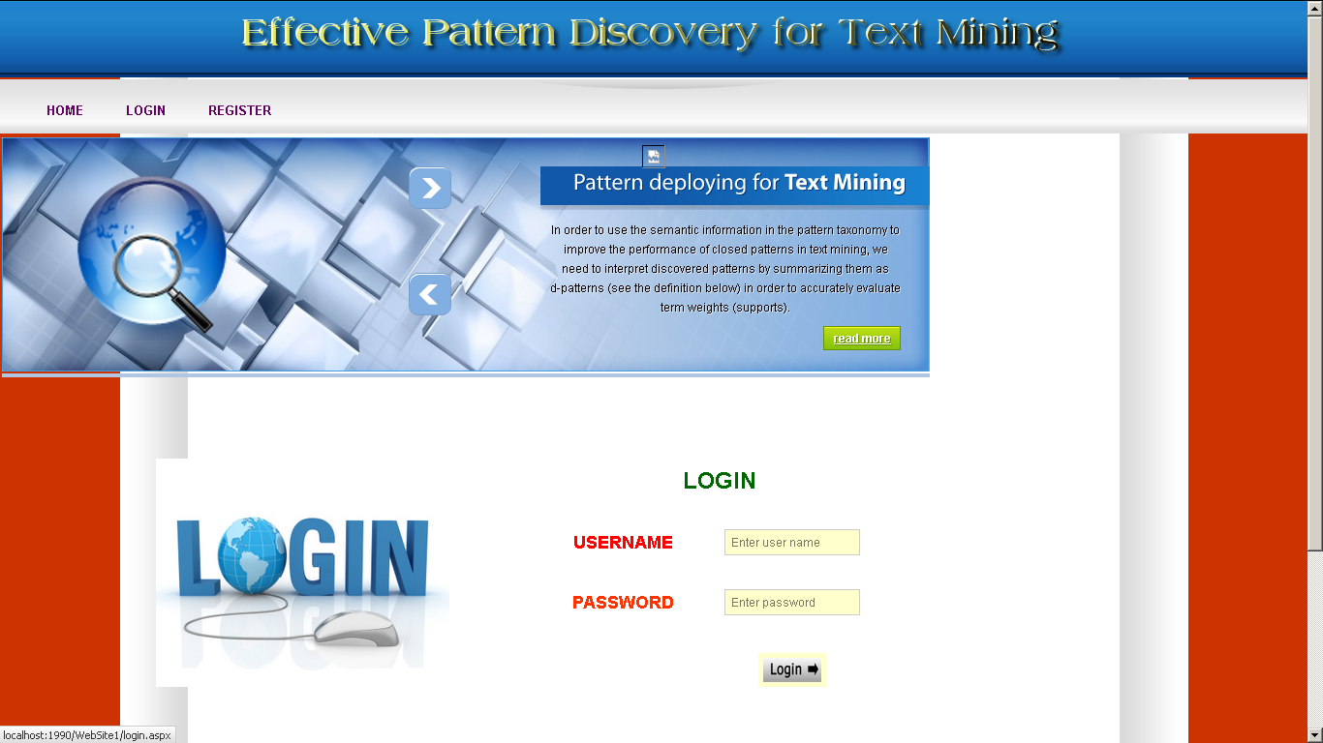

**Registration Page:**

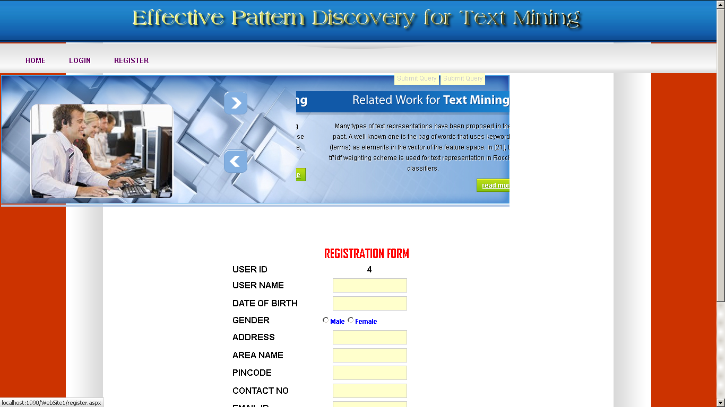

**Admin**

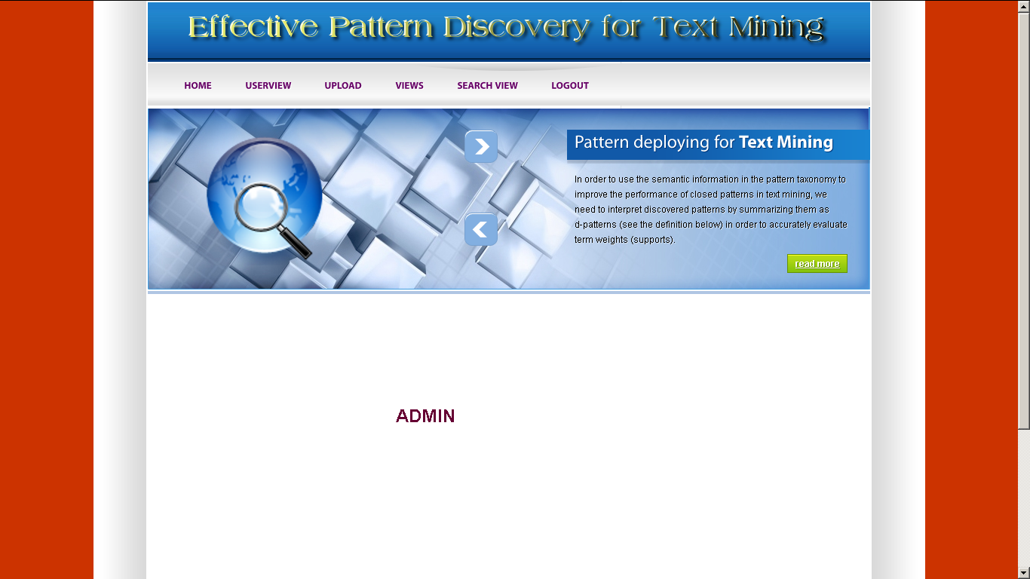

**User view**

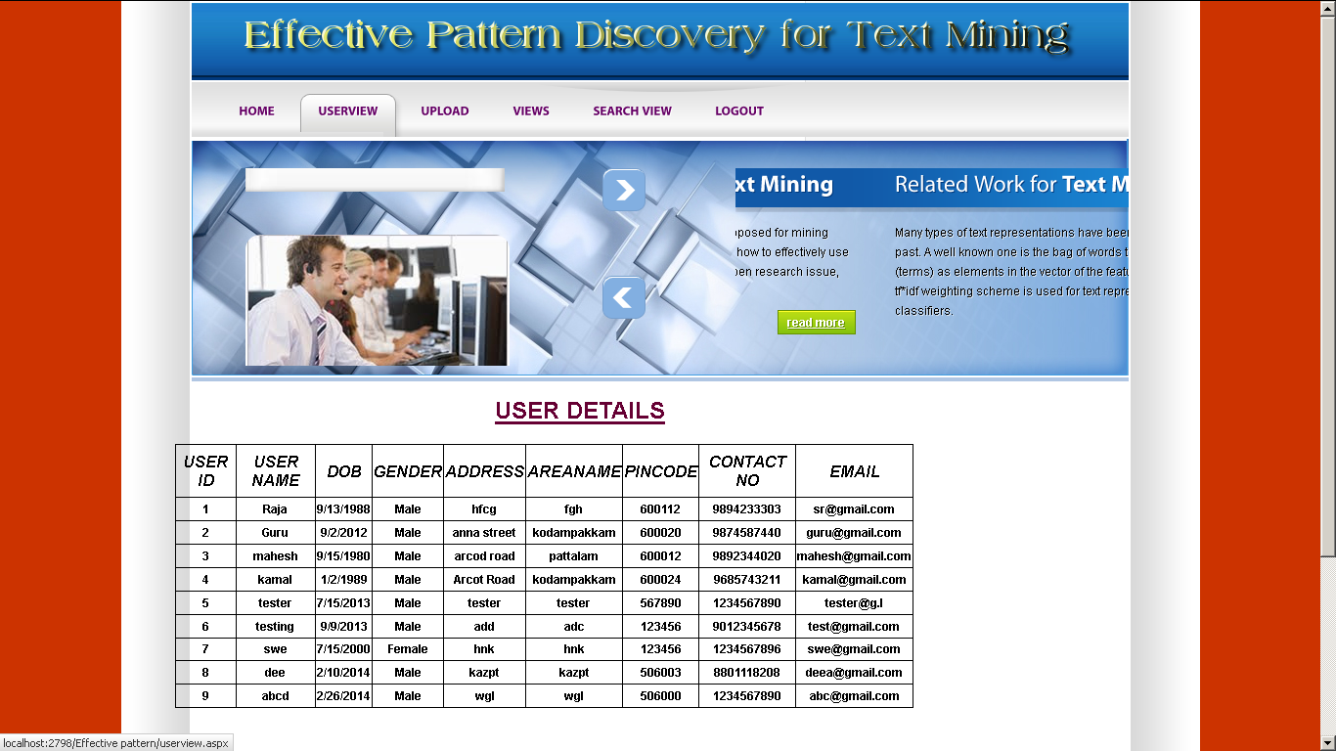

**Full file upload**

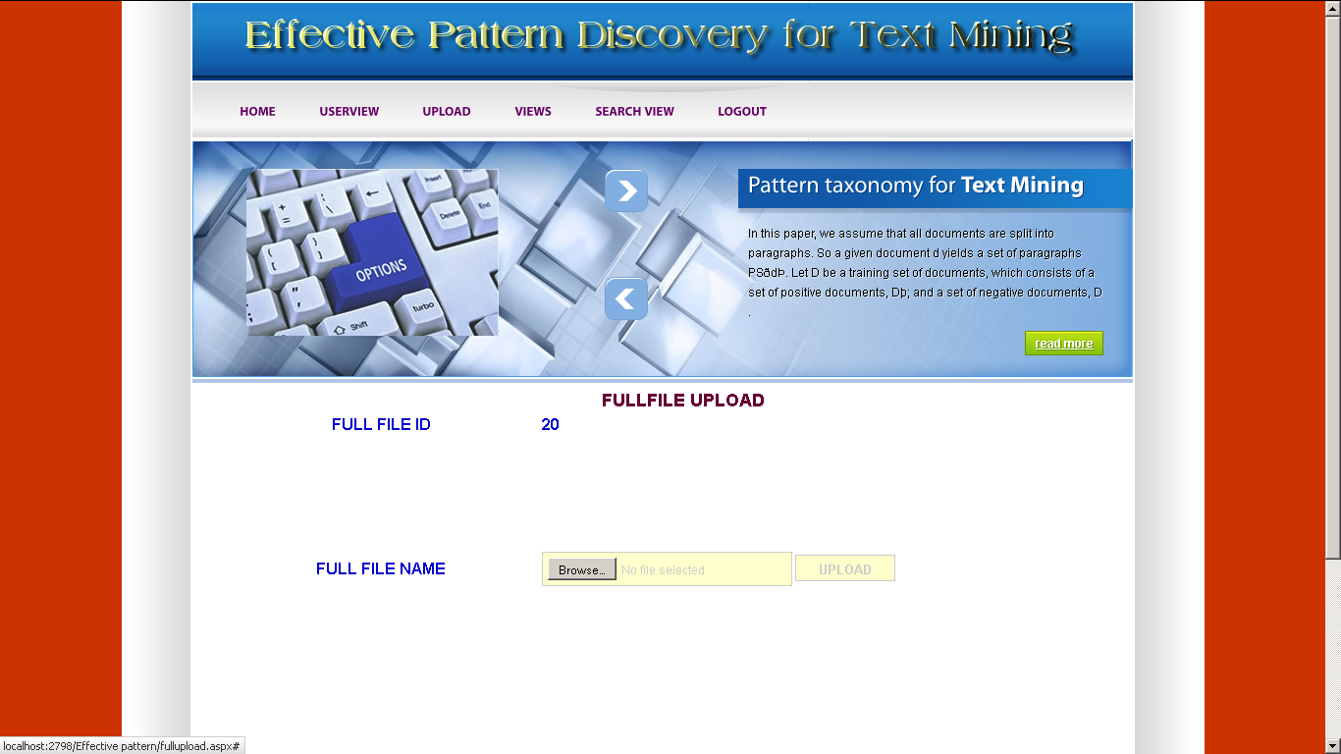

**Views**

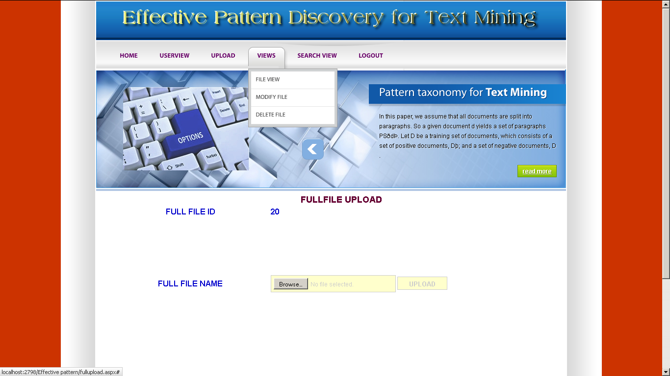

**Search**

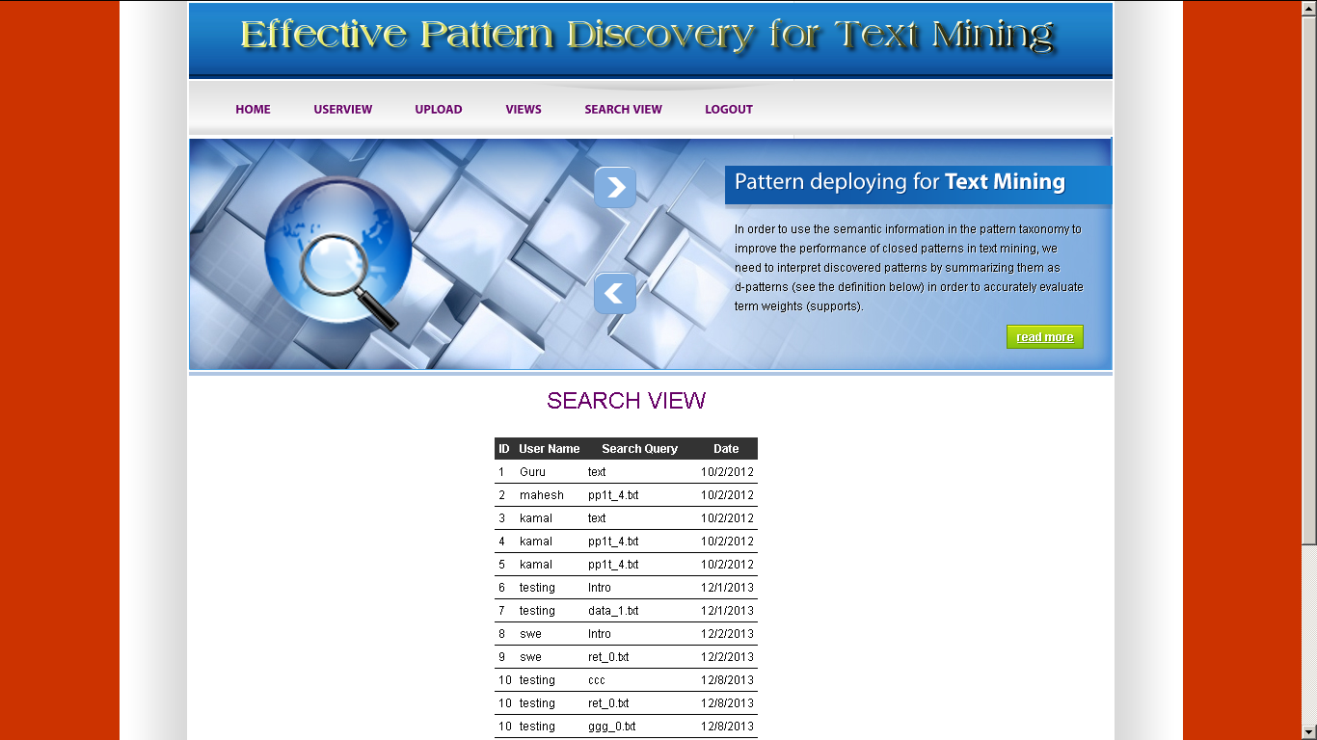

**Welcome screen User**

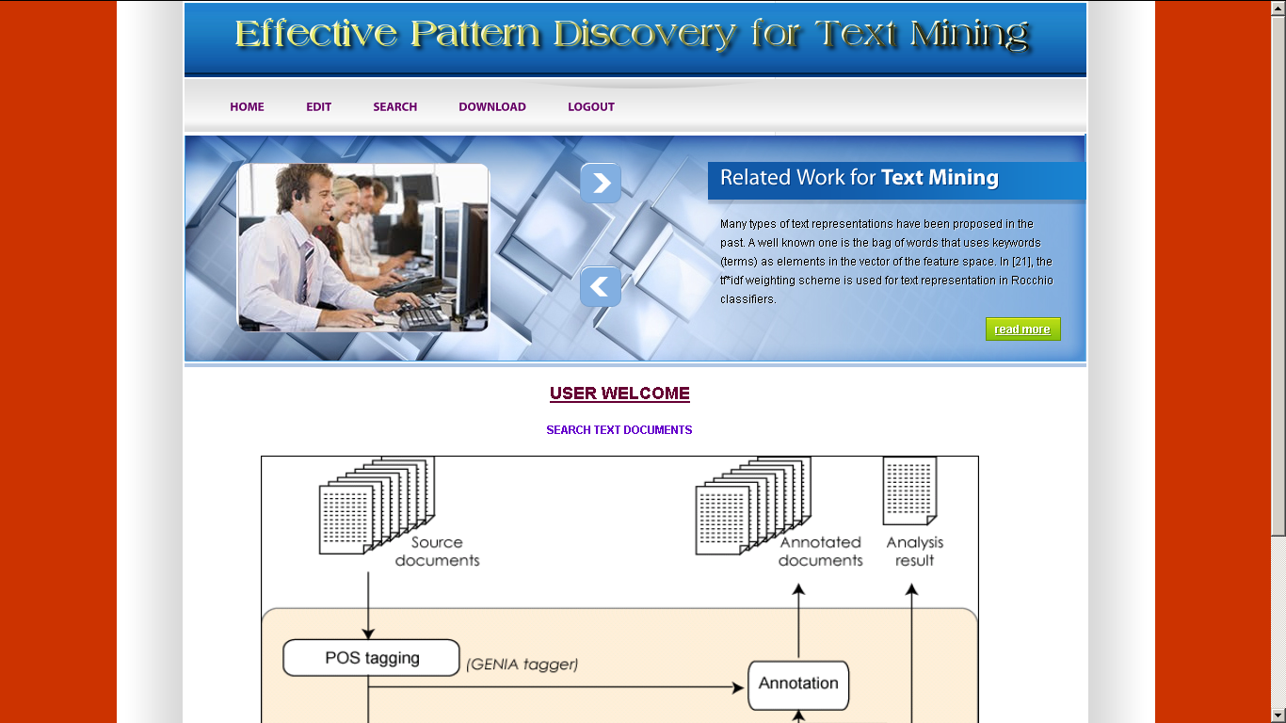

**Profile edit**

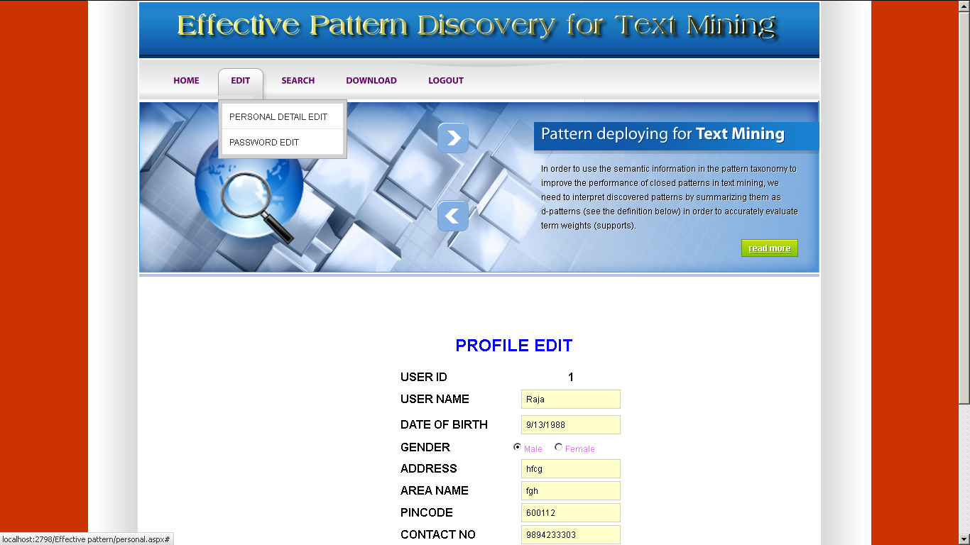

**File Search**

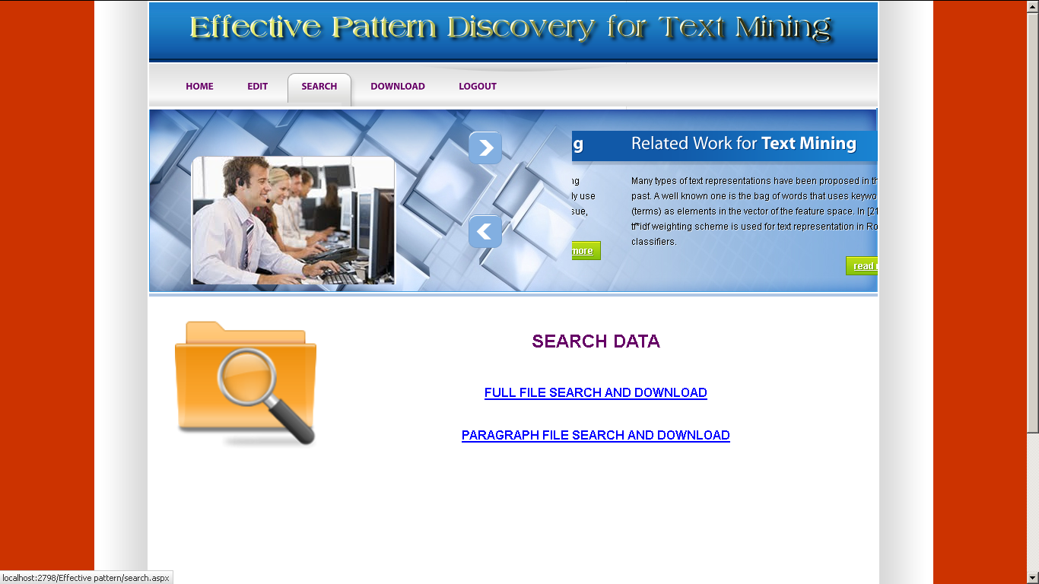

**File Download**

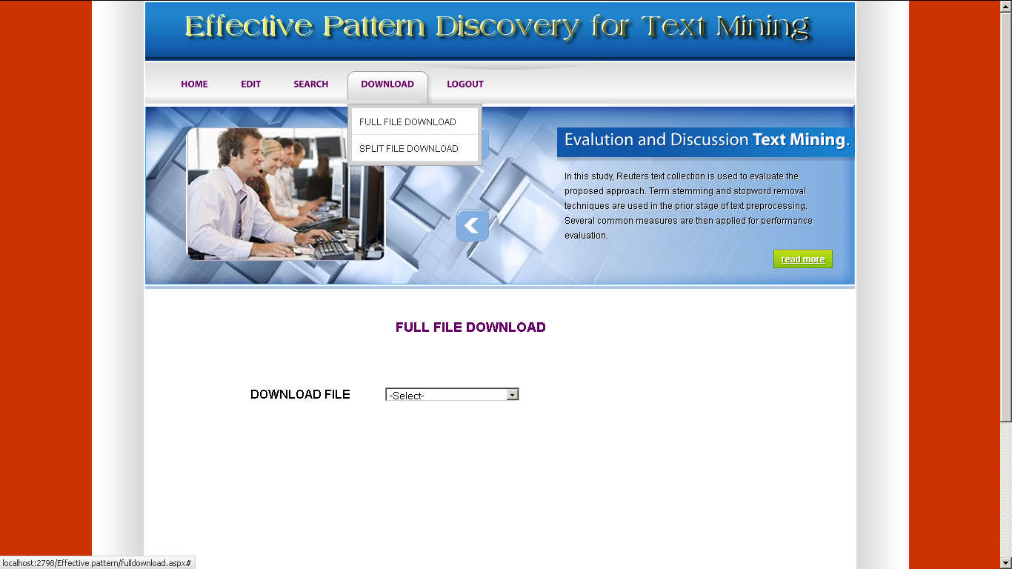

**Database Tables:**

**Full file**

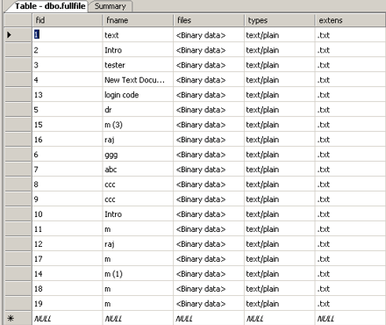

**History**

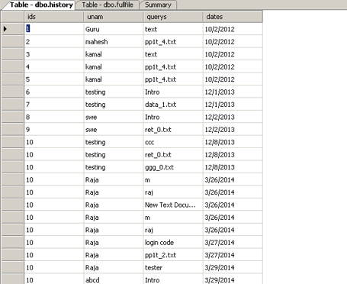

**Register**

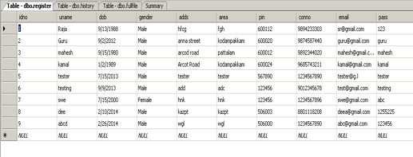

**Upload**

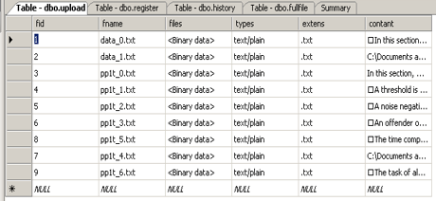

### 9. SYSTEM TESTING

The purpose of testing is to discover errors. Testing is the process of trying to discover every conceivable fault or weakness in a work product. It provides a way to check the functionality of components, sub-assemblies, assemblies and/or a finished product It is the process of exercising software with the intent of ensuring that the Software system meets its requirements and user expectations and does not fail in an unacceptable manner. There are various types of test. Each test type addresses a specific testing requirement.

**TYPES OF TESTS**

**Unit testing**

Unit testing involves the design of test cases that validate that the internal program logic is functioning properly, and that program inputs produce valid outputs. All decision branches and internal code flow should be validated. It is the testing of individual software units of the application .it is done after the completion of an individual unit before integration. This is a structural testing, that relies on knowledge of its construction and is invasive. Unit tests perform basic tests at component level and test a specific business process, application, and/or system configuration. Unit tests ensure that each unique path of a business process performs accurately to the documented specifications and contains clearly defined inputs and expected results.

**Integration testing**

Integration tests are designed to test integrated software components to determine if they actually run as one program. Testing is event driven and is more concerned with the basic outcome of screens or fields. Integration tests demonstrate that although the components were individually satisfaction, as shown by successfully unit testing, the combination of components is correct and consistent. Integration testing is specifically aimed at exposing the problems that arise from the combination of components.

**Functional test**

Functional tests provide systematic demonstrations that functions tested are available as specified by the business and technical requirements, system documentation, and user manuals.

Functional testing is centered on the following items:

**Valid Input : identified classes of valid input must be accepted.**

**Invalid Input : identified classes of invalid input must be rejected.**

**Functions : identified functions must be exercised.**

**Output : identified classes of application outputs must be exercised.**

**Systems/Procedures: interfacing systems or procedures must be invoked.**

Organization and preparation of functional tests is focused on requirements, key functions, or special test cases. In addition, systematic coverage pertaining to identify Business process flows; data fields, predefined processes, and successive processes must be considered for testing. Before functional testing is complete, additional tests are identified and the effective value of current tests is determined.

**System Test**

System testing ensures that the entire integrated software system meets requirements. It tests a configuration to ensure known and predictable results. An example of system testing is the configuration oriented system integration test. System testing is based on process descriptions and flows, emphasizing pre-driven process links and integration points.

**White Box Testing**

White Box Testing is a testing in which in which the software tester has knowledge of the inner workings, structure and language of the software, or at least its purpose. It is purpose. It is used to test areas that cannot be reached from a black box level.

**Black Box Testing**

Black Box Testing is testing the software without any knowledge of the inner workings, structure or language of the module being tested. Black box tests, as most other kinds of tests, must be written from a definitive source document, such as specification or requirements document, such as specification or requirements document. It is a testing in which the software under test is treated, as a black box .you cannot “see” into it. The test provides inputs and responds to outputs without considering how the software works.

**9.1 Unit Testing:**

Unit testing is usually conducted as part of a combined code and unit test phase of the software lifecycle, although it is not uncommon for coding and unit testing to be conducted as two distinct phases.

**Test strategy and approach**

Field testing will be performed manually and functional tests will be written in detail.

**Test objectives**

* All field entries must work properly.
* Pages must be activated from the identified link.
* The entry screen, messages and responses must not be delayed.

**Features to be tested**

* Verify that the entries are of the correct format
* No duplicate entries should be allowed
* All links should take the user to the correct page.

# 9.2 Integration Testing

Software integration testing is the incremental integration testing of two or more integrated software components on a single platform to produce failures caused by interface defects.

The task of the integration test is to check that components or software applications, e.g. components in a software system or – one step up – software applications at the company level – interact without error.

**Test Results:** All the test cases mentioned above passed successfully. No defects encountered.

**9.3 Acceptance Testing**

User Acceptance Testing is a critical phase of any project and requires significant participation by the end user. It also ensures that the system meets the functional requirements.

**Test Results:** All the test cases mentioned above passed successfully. No defects encountered.

**10. FUTURE SCOPE & CONCLUSION**

Many data mining techniques have been proposed in the last decade. These techniques include association rule mining, frequent item set mining, sequential pattern mining, maximum pattern mining, and closed pattern mining. However, using these discovered knowledge (or patterns) in the field of text mining is difficult and ineffective. The reason is that some useful long patterns with high specificity lack in support (i.e., the low-frequency problem). We argue that not all frequent short patterns are useful. Hence, misinterpretations of patterns derived from data mining techniques lead to the ineffective performance. In this research work, an effective pattern discovery technique has been proposed to overcome the low-frequency and misinterpretation problems for text mining. The proposed technique uses two processes, pattern deploying and pattern evolving, to refine the discovered patterns in text documents. The experimental results show that the proposed model outperforms not only other pure data mining-based methods and the concept based model, but also term-based state-of-the-art models, such as BM25 and SVM-based models.

**11. References**

**References Made From:**

1. [**Beginning ASP.NET 4: in C# and VB**](http://www.amazon.com/gp/product/0470502215?ie=UTF8&tag=aspnettelligent-20&linkCode=as2&camp=1789&creative=9325&creativeASIN=0470502215)by *Imar Spaanjaars*.
2. [**Programming ASP.NET 3.5**](http://www.amazon.com/gp/product/0596529562?ie=UTF8&tag=aspnettelligent-20&linkCode=as2&camp=1789&creative=9325&creativeASIN=0596529562)*by Jesse Liberty, Dan Maharry, Dan Hurwitz.*
3. S. Kamara and K. Lauter, “Cryptographic cloud storage,” in RLCPS, January 2010, LNCS. Springer, Heidelberg.
4. D. Song, D. Wagner, and A. Perrig, “Practical techniques for searches on encrypted data,” in *Proc. of S&P*, 2000.
5. [**Beginning ASP.NET 3.5 in C# 2008: From Novice to Professional, Second Edition**](http://www.amazon.com/gp/product/1590598911?ie=UTF8&tag=aspnettelligent-20&linkCode=as2&camp=1789&creative=9325&creativeASIN=1590598911)by *Matthew MacDonald.*
6. Y.-C. Chang and M. Mitzenmacher, “Privacy preserving keyword searches on remote encrypted data,” in *Proc. of ACNS*, 2005.
7. C. Wang, N. Cao, J. Li, K. Ren, and W. Lou, “Secure ranked keyword search over encrypted cloud data,” in Proc. of ICDCS’10,2010.
8. P. Mell and T. Grance, “Draft nist working definition of cloud computing,” Referenced on Jan. 23rd, 2010.
9. M. Armbrust, A. Fox, R. Griffith, A. D. Joseph, R. H. Katz, A. Konwinski, G. Lee, D. A. Patterson, A. Rabkin, I. Stoica, and M. Zaharia, “Above the clouds: A berkeley view of cloud computing,” University of California, Berkeley, Tech. Rep. UCBEECS- 2009-28, Feb 2009

**Sites Referred:**

* <http://www.asp.net.com>
* <http://www.dotnetspider.com/>
* <http://www.dotnetspark.com>
* [http://www.cs.cmu.edu/*»*enron/](http://www.cs.cmu.edu/).
* <http://csrc.nist.gov/groups/SNS/cloud-computing/index.html>